**12) BigQuery concepts**

Step 1 : Create a dataset inside project first

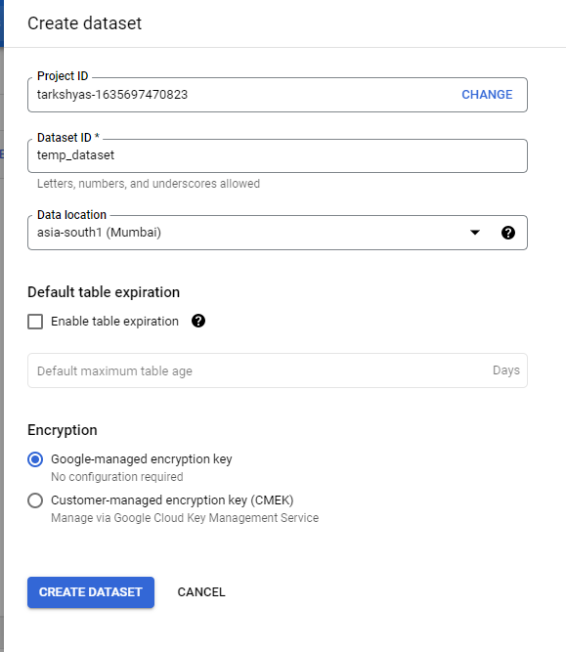

Step 2 : Create a table inside the dataset and upload csv file which contains data. Also we can upload files from cloud storage too.

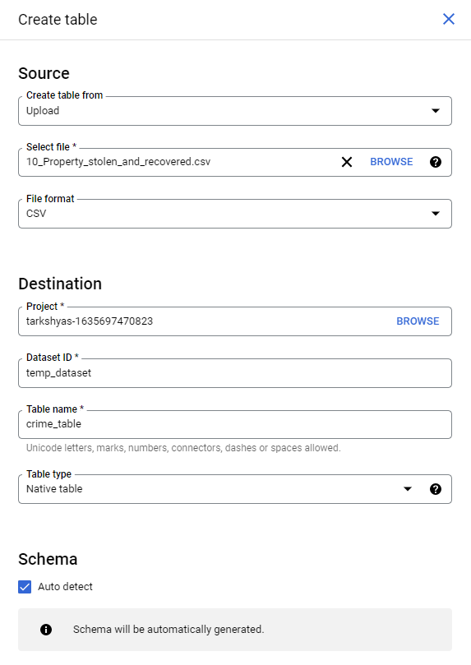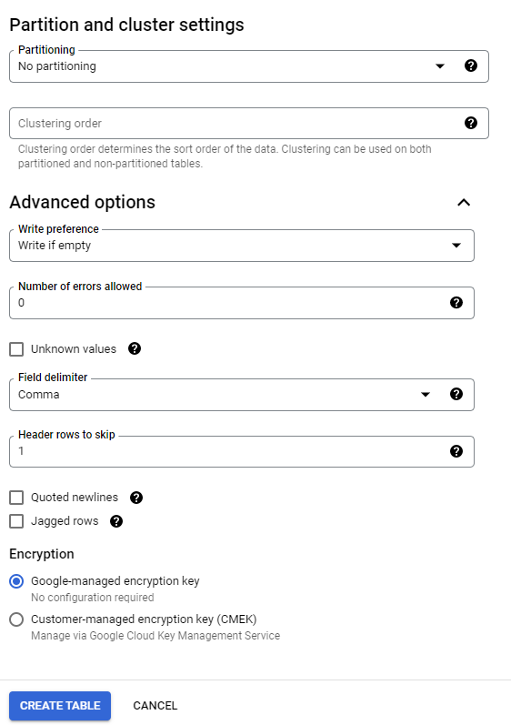

Step 3 : Dataset and table created are,

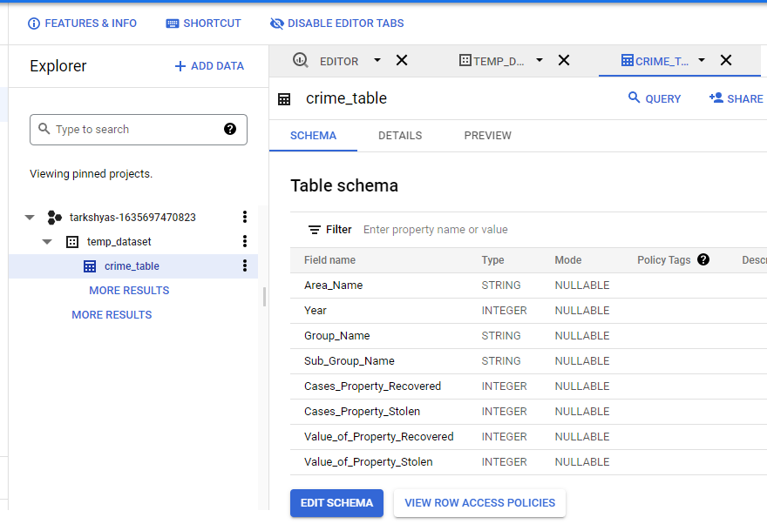

**-- GROUP BY & HAVING --**

Step 4 : Run the query to group data by year,area_name and group_name in the year 2001

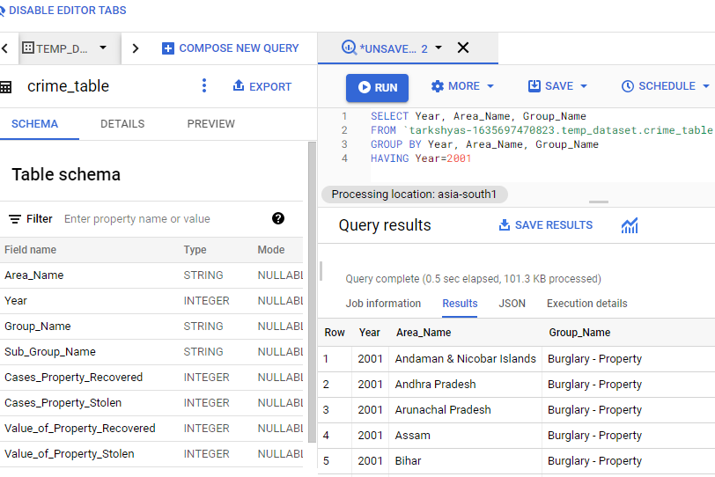

Step 5 : This query result can be stored in a new table ie, result_table

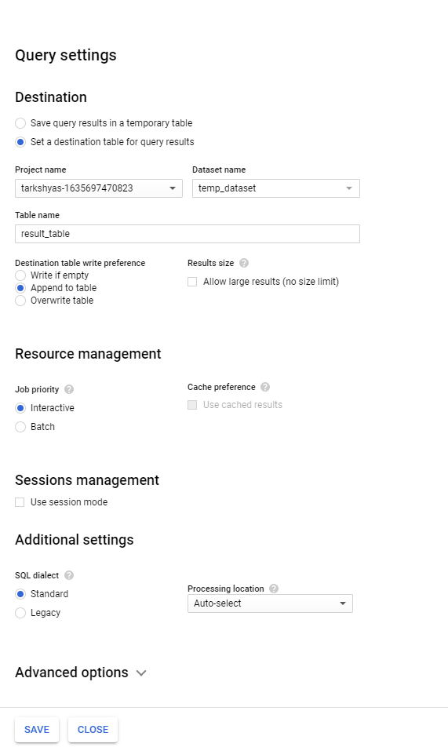

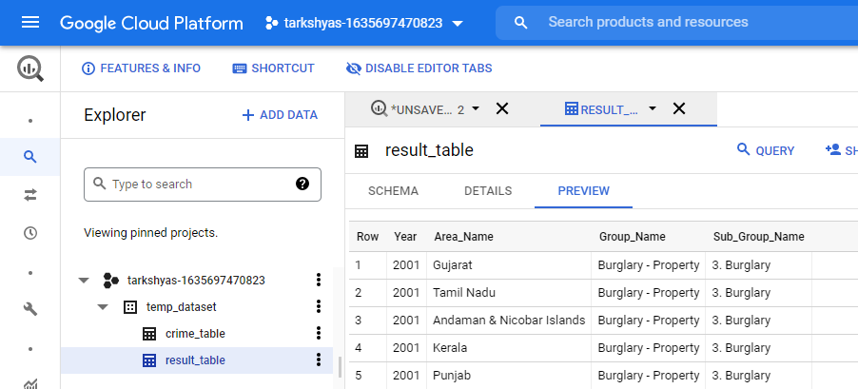

**-- JOIN QUERY --**

Step 6 : Create name table and hour table and join both tables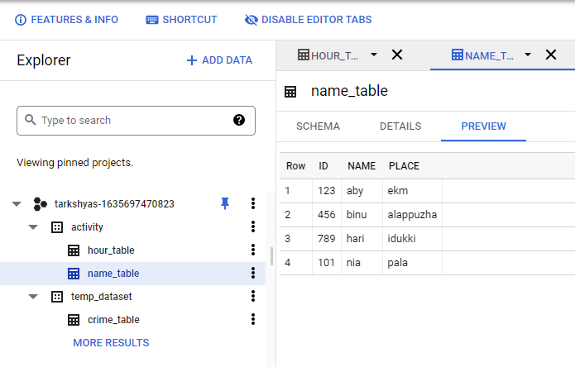

Step 7 : Resultant table after joining

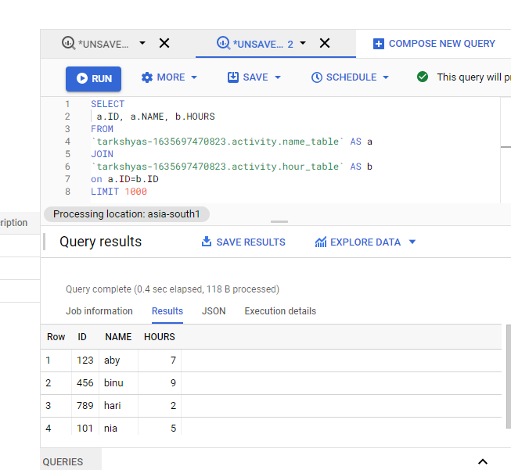

**-- WILD CARD QUERY –**

Step 8 : Create two tables with common names such as student_1 and student_2



Step 9 : After executing the query the resultant table will displays all the contents in both tables.

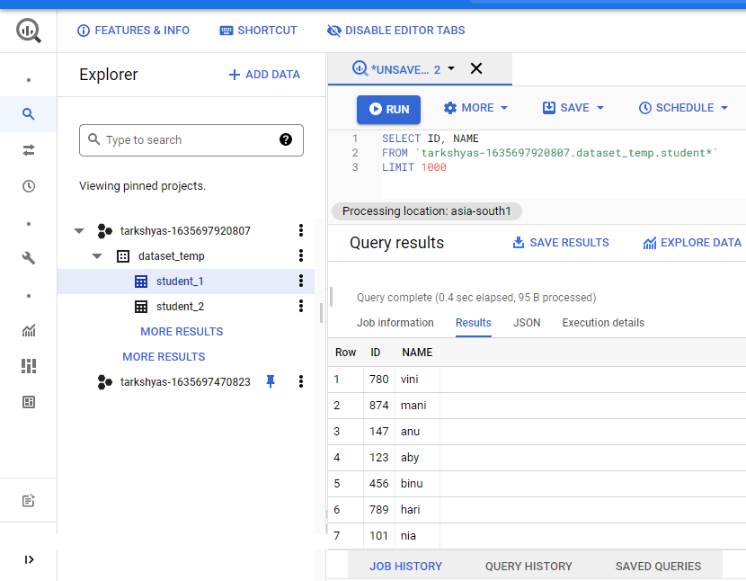

**-- PARTITIONING & CLUSTERING –**

Step 10 : Create dataset and table , then upload file to be partitioned . Here the hacker table contents are :

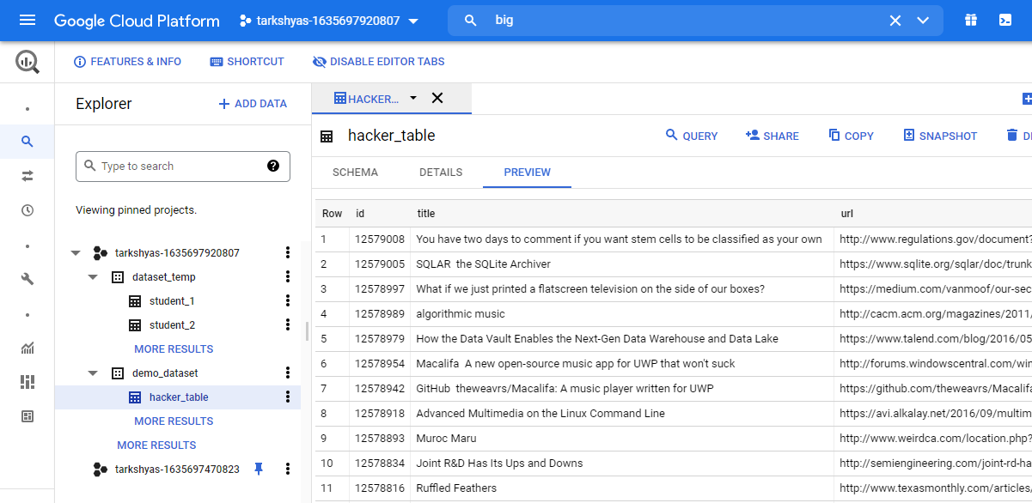

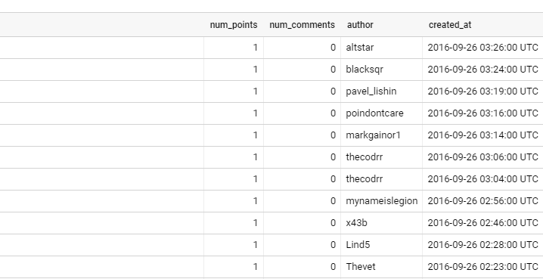

Step 11 : Clean that table so that we need to avoid the time in the row created_at and filter the date only

***Table_1 before cleansing***

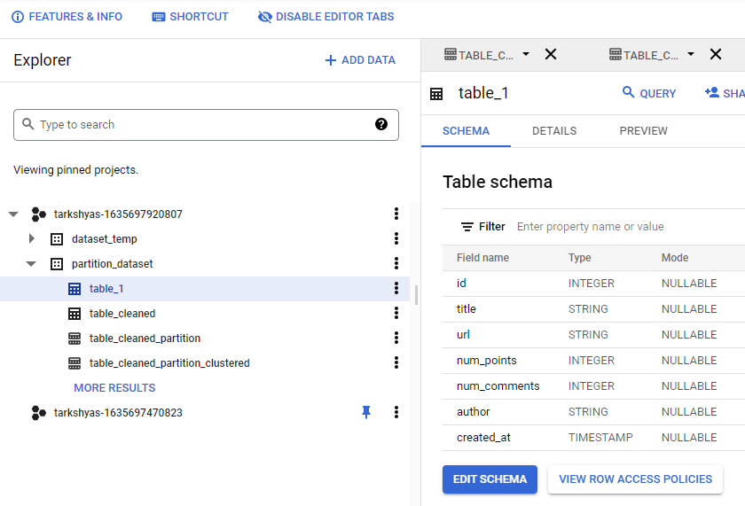

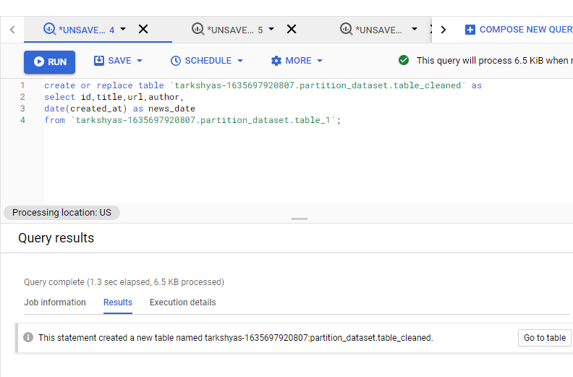

***Table_cleaned***

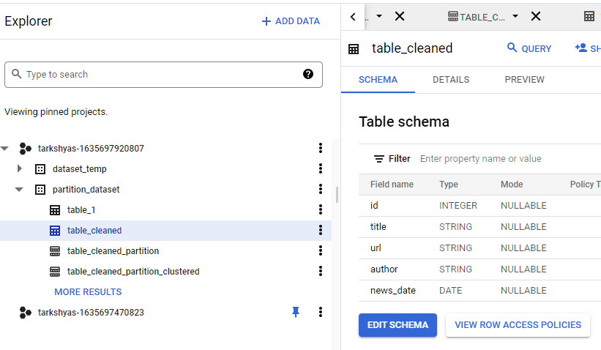

Step 12 : Partition the table based on their news_date so that tables are divided into different groups with similar date

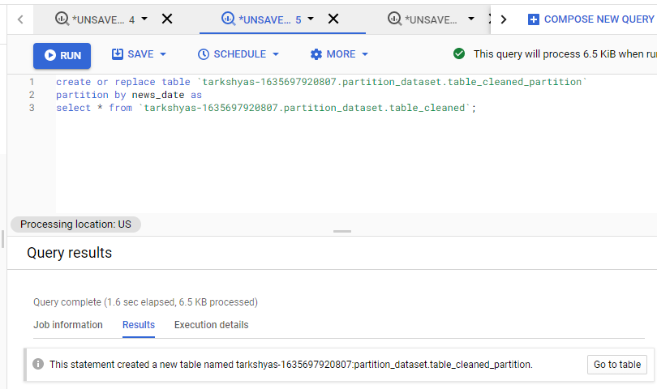

***Partitioned_table***

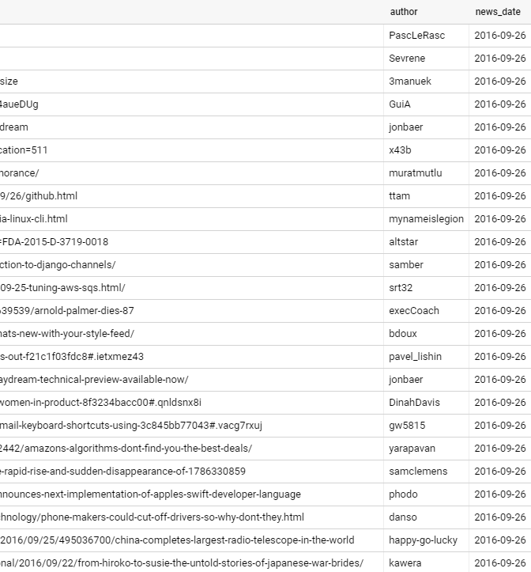

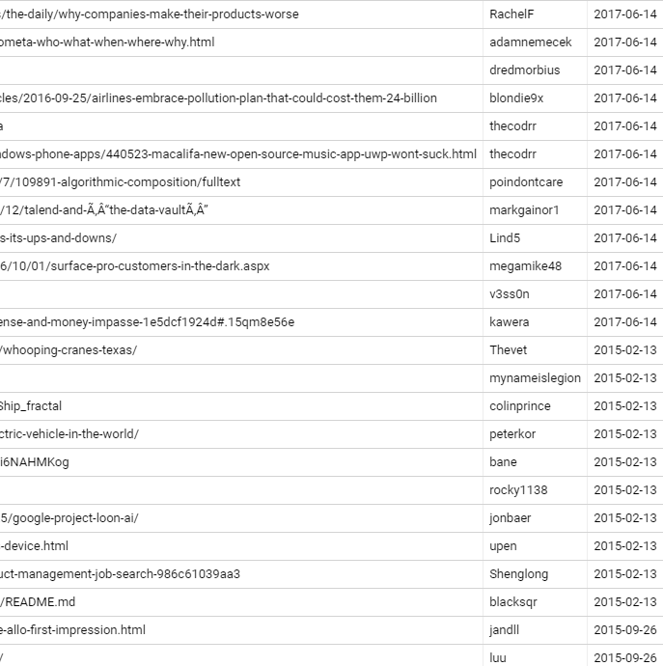

Step 13 : Group together the data with similar author in the partitioned table using cluster query.

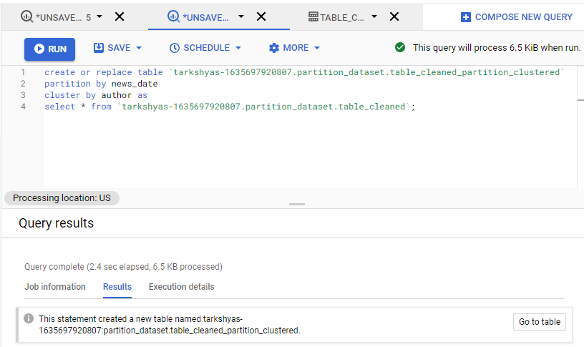

***Clustered_table***

